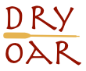

- primary-color: #455F48
- secondary-color: #DFEAD6
- accent1-color: #13315C
- accent2-color: #A7CAF1

- heading-font: Rammetto One
- text-font: Sarala

https://coolors.co/455f48-dfead6-13315c-a7caf1

